LM35

Precision Centigrade Temperature Sensors

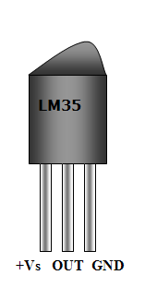

General Description:

The LM35 series are precision integrated-circuit temperature sensors, whose output voltage is linearly proportional to the Celsius (Centigrade) temperature. The LM35 thus has an advantage over linear temperature sensors calibrated in Kelvin, as the user is not required to subtract a large constant voltage from its output to obtain convenient Centigrade scaling. The LM35 does not require any external calibration or trimming to provide typical accuracies of ±1⁄4°C at room temperature and ±3⁄4°C over a full −55 to +150°C temperature range. Low cost is assured by trimming and calibration at the wafer level. The LM35’s low output impedance, linear output, and precise inherent calibration make interfacing to readout or control circuitry especially easy. It can be used with single power supplies, or with plus and minus supplies. As it draws only 60 μA from its supply, it has very low self-heating, less than 0.1°C in still air. The LM35 is rated to operate over a −55° to +150°C temperature range, while the LM35C is rated for a −40° to +110°C range (−10° with improved accuracy). The LM35 series is available packaged in hermetic TO-46 transistor packages, while the LM35C, LM35CA, and LM35D are also available in the plastic TO-92 transistor package. The LM35D is also available in an 8-lead surface mount small outline package and a plastic TO-220 package.

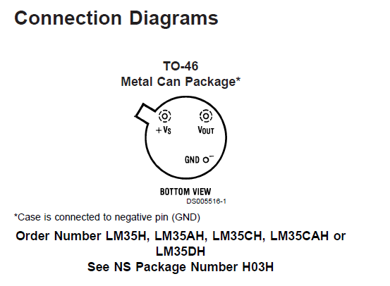

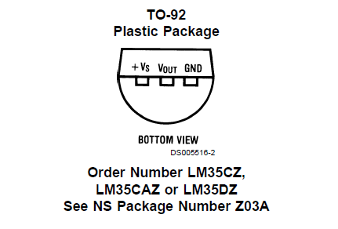

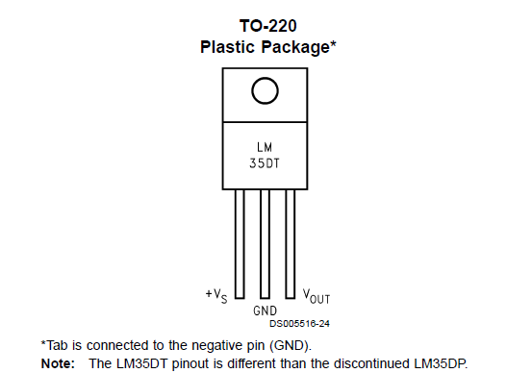

Applications:

The LM35 can be applied easily in the same way as other integrated-circuit temperature sensors. It can be glued or cemented to a surface and its temperature will be within about 0.01°C of the surface temperature. This presumes that the ambient air temperature is almost the same as the surface temperature; if the air temperature were much higher or lower than the surface temperature, the actual temperature of the LM35 die would be at an intermediate temperature between the surface temperature and the air temperature. This is expecially true for the TO-92 plastic package, where the copper leads are the principal thermal path to carry heat into the device, so its temperature might be closer to the air temperature than to the surface temperature. To minimize this problem, be sure that the wiring to the LM35, as it leaves the device, is held at the same temperature as the surface of interest. The easiest way to do this is to cover up these wires with a bead of epoxy which will insure that the leads and wires are all at the same temperature as the surface, and that the LM35 die’s temperature will not be affected by the air temperature. The TO-46 metal package can also be soldered to a metal surface or pipe without damage. Of course, in that case the V− terminal of the circuit will be grounded to that metal. Alternatively, the LM35 can be mounted inside a sealed-end metal tube, and can then be dipped into a bath or screwed into a threaded hole in a tank. As with any IC, the LM35 and accompanying wiring and circuits must be kept insulated and dry, to avoid leakage and corrosion. This is especially true if the circuit may operate at cold temperatures where condensation can occur. Printed-circuit coatings and varnishes such as Humiseal and epoxy paints or dips are often used to insure that moisture cannot corrode the LM35 or its connections. These devices are sometimes soldered to a small light-weight heat fin, to decrease the thermal time constant and speed up the response in slowly-moving air. On the other hand, a small thermal mass may be added to the sensor, to give the steadiest reading despite small deviations in the air temperature.

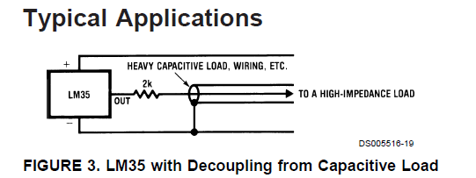

Features:

Calibrated directly in ° Celsius (Centigrade) Linear + 10.0 mV/°C scale factor 0.5°C accuracy guaranteeable (at +25°C) Rated for full −55° to +150°C range Suitable for remote applications Low cost due to wafer-level trimming Operates from 4 to 30 volts Less than 60 μA current drain Low self-heating, 0.08°C in still air Nonlinearity only ±1⁄4°C typical Low impedance output, 0.1 Ω for 1 mA load

